QUESTION #1:
Main Code:

#include <stdio.h>
#include <math.h>

struct address_t {
char name[15];
int aa;
int bb;
int cc;
int dd;
};

int localnet (struct address_t one, struct address_t two) {
return(one.aa == two.aa && one.bb == two.bb);
}

int main() {
FILE *data = fopen("L8_ip.txt", "r");

struct address_t person[300];

int i = 0;
int j = 0;

while(!feof(data)) {
fscanf(data, "%d.%d.%d.%d %s", &person[i].aa, &person[i].bb, &person[i].cc, &person[i].dd, person[i].name);
i++;
j++;
}

for (int i = 0; i<300; i++) {
for (int j = i+1; j<300; j++) {
if (localnet(person[i], person[j])) {
printf("\nServers %s and %s are on the same local network.", person[i].name, person[j].name);
}
if (person[i].aa == 0) {
return(0);
}
}
}
}

Output:
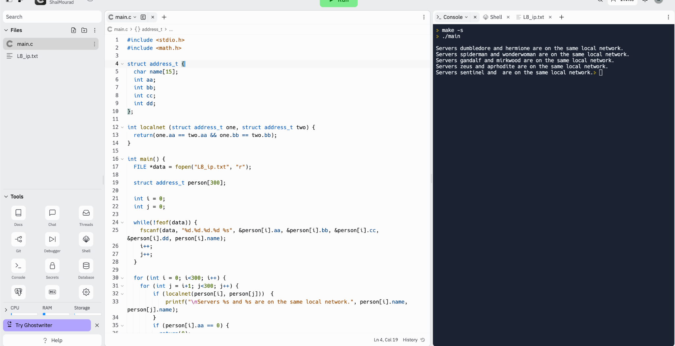

QUESTION #2:

Main Code:

#include "mylibrary.h"
#include <stdio.h>
#include <stdlib.h>
#include <string.h>

int main() {
FILE *data = fopen("L8_real.txt", "r");

double nums[10][10];

for (int i = 0; i < 10; i++) {
for (int j = 0; j < 10; j++) {
fscanf(data, "%lf", &nums[i][j]);
}
}
fclose(data);

sumdiag(nums);

sumall(nums);

avright(nums);

corners(nums);

largeanti(nums);

FILE *results;

results = fopen("results.bin", "w");
fprintf(results, "The sum of the diagonal is: %.1lf.\nThe sum of all of the values is: %.1lf.\nThe average of the right most column is: %.1lf.\nThe sum of the corners is: %.1lf.\nThe largest value in the antidiagonal is: %.1lf.", sumdiag(nums), sumall(nums),
avright(nums), corners(nums), largeanti(nums));
}

My Library:

double sumdiag(double array[10][10]) {
double c = 0;
int i = 0;
int j = 0;
while (i < 10 && j < 10) {
c = c + array[i][j];
i++;
j++;
}
return c;
}

double sumall(double array[10][10]) {
double c1 = 0;
int i = 0;
int j = 0;
while (j < 10) {
c1 = c1 + array[i][j];
i++;
if (i == 10) {
i = 0;
j++;
}
}
return c1;
}

double avright(double array[10][10]) {
double c2 = 0;
for (int i = 0; i < 10; i++) {
c2 = c2 + array[i][9];
}
c2 = c2 / 10;
return c2;
}

double corners(double array[10][10]) {
double c3 = 0;
c3 = array[0][0] + array[0][9] + array[9][0] + array[9][9];
return c3;
}

double largeanti(double array[10][10]) {
double largest = 0;
for (int i = 0; i < 10; i++) {
for (int j = 9; j >= 0; j--) {
if (array[i][j] > largest) {
largest = array[i][j];
}
}
}
return largest;
}

Output:

